Rotax 914 Carb Drip Trays

Erich Trombley and Jim Butcher

Eventually when troubleshooting a Rotax engine, you will be directed to drop the float bowls to look for contamination or leaks. That’s pretty easy to do on a 912 or 912S because the bowl is held in place with just a spring wire. Pop the wire and pull down the bowl.

On a 914, the bowl is pressurized and held in place with a bolt from the bottom. And the early engines were equipped with very nice but large drip trays. Here’s a photo

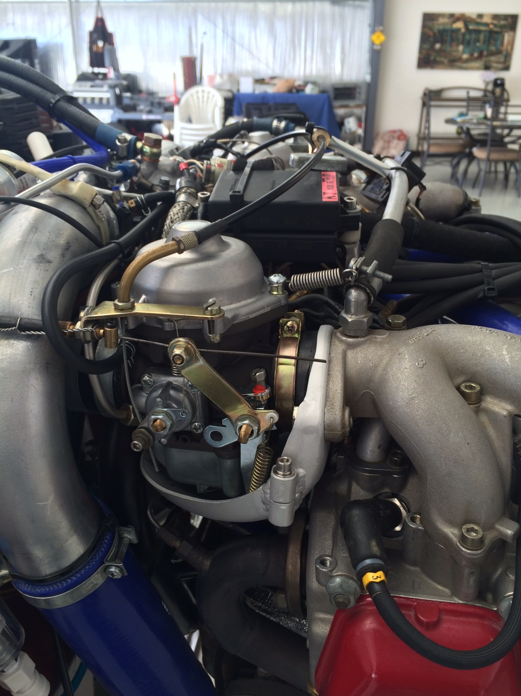

To get the bowl off, you have to either remove the airbox and then the carbs from the intake manifold or unbolt the intake manifold from the head. In either case, it is not quick and simple and you will probably tip and slosh out the fuel in the bowl, not to mention the possibility of creating leaks and maybe the need to disconnect throttle and choke cables which then require carb balance.

Erich Trombley faced this problem on his trip home from Oshkosh in 2015. He vowed “never again” and came up with a neat, simple solution. He cut drip trays as shown below and welded threaded bosses to allow removal portion of the tray under the bowl.

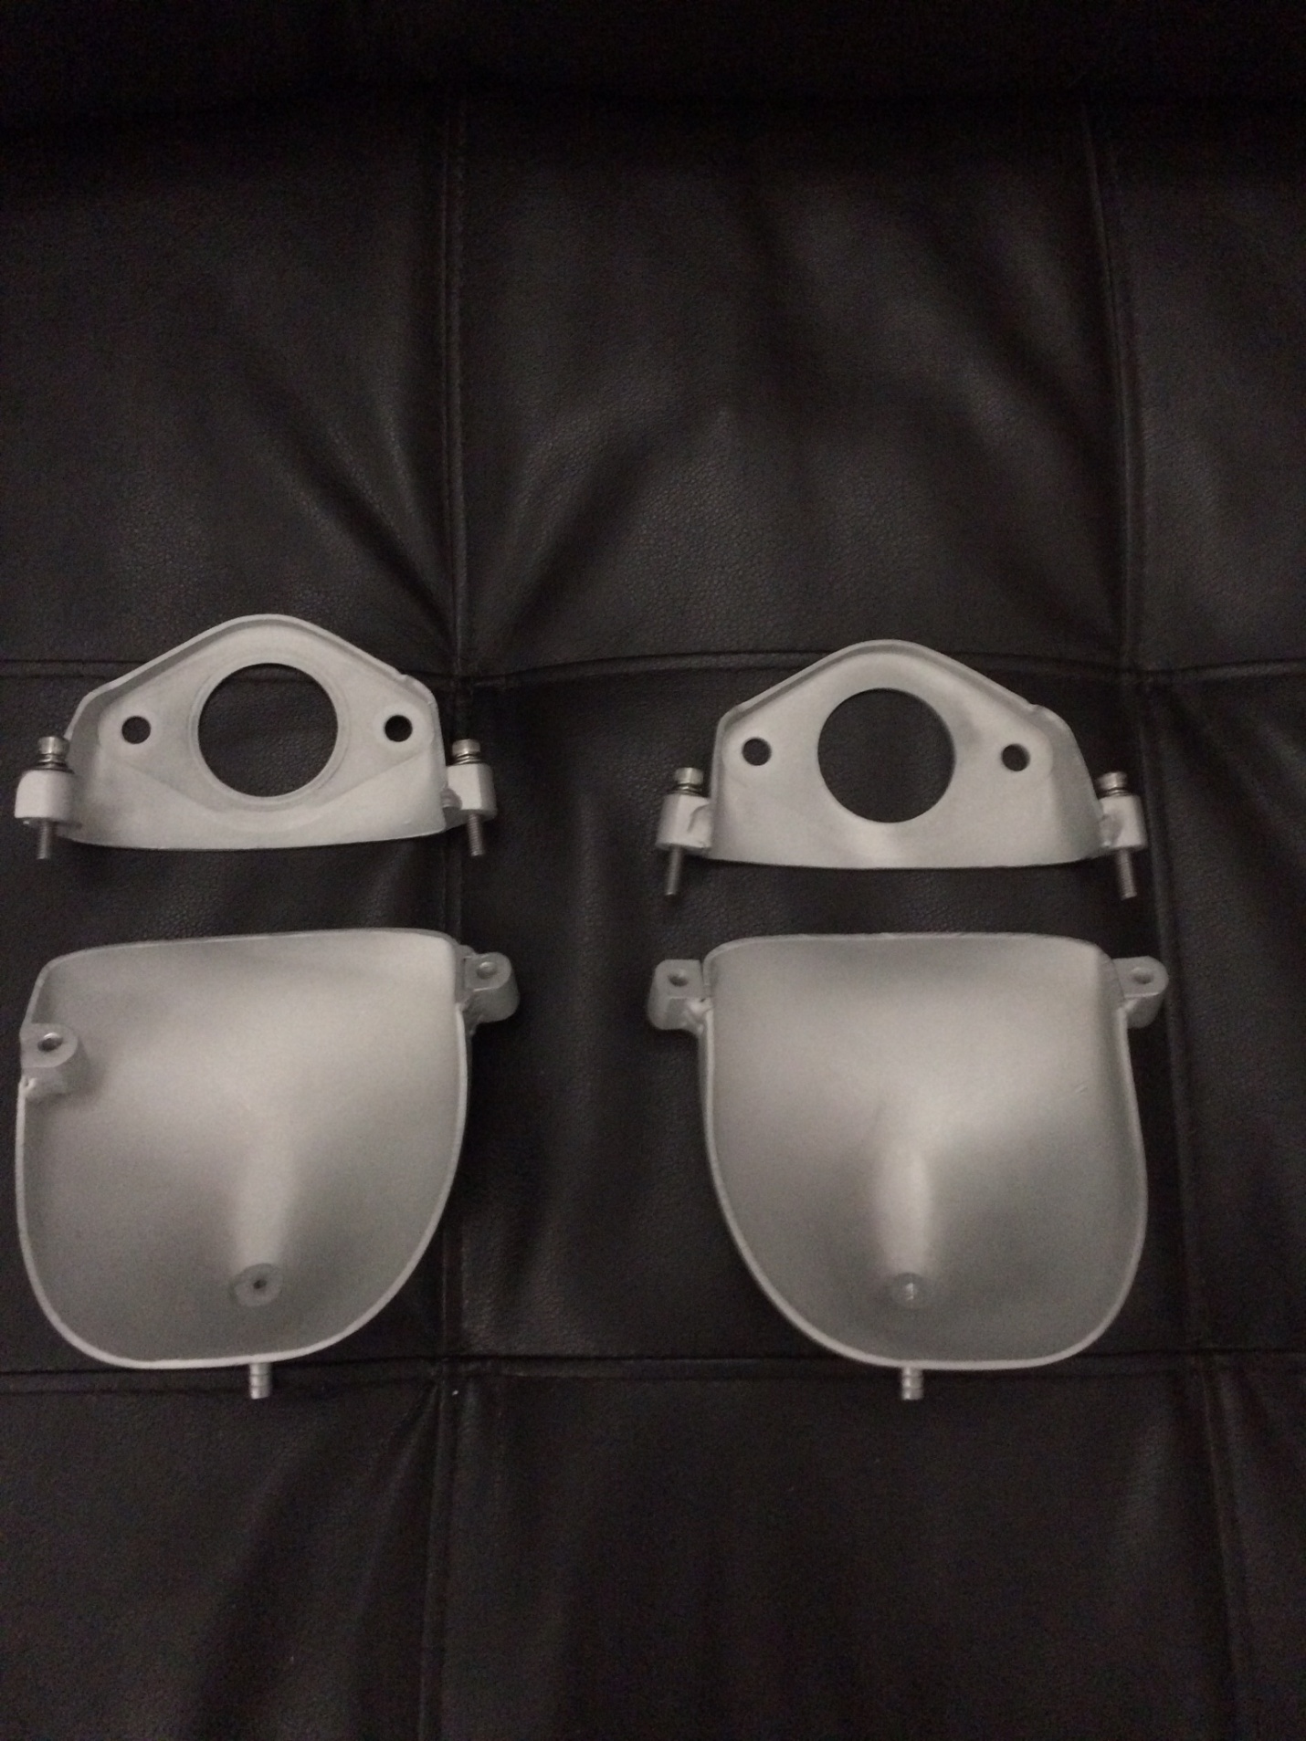

That gives access to the bolt and then the bowl. Note that the boss on the starboard drip tray is welded inboard to clear the ignition coils. He just uses machine screws with loctite to hold the trays together.