I’m tired of the Drip, Drip, Drip!
Catching 914 Oil Drips from flying and after Long Term Storage
The Final Solution for N12AY
By
Bud Yerly

I’m sick of that steady drip, drip, drip. I’m to blame that I don’t fly 12AY as much as I should. Since I had an overspeed and I noticed the compression falling off on one cylinder, I decided to do a 500-hour top overhaul and gearbox servicing. I asked Kerry Yunk, at Lockwood to do my gearbox and pull the cylinders and take a look. I asked him to dress or replace the valves and fix and repair as necessary. I knew my valves touched the pistons in the overspeed and although unnecessary, I had Kerry changed all 4 intake valves and had him lap all the seats. Everything in the engine was like new. However, since the valve and cylinder cleanup there is a serious difference in compression while turning it over to burp it. It is like a 912S now. My compression checks are 79+/80.

I had an oil leak from the gearbox and it required a redo of the sealant. I expected some issues after maintenance. The gearbox leak aside, I am writing this because over the many years I’ve had this engine, it has always had a small puddle of oil on the hangar floor from three or four sources.
These sources are common drips on a properly functioning 914. The oil tank vent, the turbo inlet dripping from the turbo mouth through the filter, and the intake plenum and the various 914 required drain hoses. Each of these contribute to an oily nose pant, belly and tiny floor puddles.

Nothing good happens when an engine sets unused. When the engine sets for a while, there are static and dynamic leaks. (See my latest Rotax troubleshooting guide also.)

Static Leaks:
- Because the turbo is located on the bottom of the engine, it is prone to filling with oil draining out of the engine oil pump and oil supply lines through the oil pump clearances. The oil pump has tight tolerances but it will allow oil to flow past the trochoid pump internals then to the lowest point which is normally the turbo. The amount of oil seepage is not bad. The turbo is equipped with its own oil delivery line and return line and sump.
- The return is a can attached to the bottom of the tubo which is sealed with an O ring between the turbo housing and the turbo tank. These retaining screws that hold the tank to the turbo could loosen with time but not normally if a small amount of Loctite is used on the screws. This O ring is normally good for about 5 years. The turbo oil return line attaches to the oil pump via a flared fitting high on the rear of the tank and connected to the pump. There is no safety wire on this flared fitting. This fitting cannot be safety wired so a check every oil change or 25 hours is prudent.
- The turbo oil supply line has a ball check valve and spring to prevent overfilling of the tank after shutdown as oil will drain via the oil pump into the turbo when not running. Properly functioning, the oil check valve prevents oil from draining through into the turbo bearings and return tank when shut down. This ball check valve should be cleaned when oil leakage is noted around the can area. Some oil draining from the oil pump can flow past the ball check as well as from the oil suction return line from the oil pump. In the Europa XS, a drip or two of oil from under the turbo makes a mess of the top of the metal duct. See the Rotax Heavy Maintenance Manual for servicing the ball check valve.
- Anytime the 914 sits a month, the oil that leaks down from the engine through the turbo oil lines will pass through the turbo ceramic seal and flows into both the turbo inlet and exhaust side. The oil on the turbo cold side begins to pool and will flow into the air filter (see 5 below). Gravity works, so the oil completely fills the turbo cold side. If the engine is run often, it is not an issue normally. Because any oil that was in the turbo cold side (area around the intake turbine) is flung / pushed / sucked out of the turbo and blown into the carb intake plenum on startup. When the engine sets for a while, oil that collects in the carb plenum, works its way down to the two drains in the bottom of the plenum tube where there are two drain fittings with hoses to the cowl exit area also. This oil is a bit frothy from being whipped up by the turbine and it takes a while to work its way down and out of the drain lines. Note the rest of the oil coats a film on the carb insides and goes down the carb throat and into the cylinders. After shut down from a brief engine run, the accumulated oil drains down the charge hose from the turbo to the plenum and saturates the 2 inch hose connection at the turbo. Eventually the hose will soften at the joints, and oil will seep from the charge hose area, down the turbo and drip off the exterior bottom of the turbo. This is another mess on the inlet metal duct. If you note the manifold pressure comes up slowly on takeoff, check your rubber hoses between the turbo, the charge pipe, and from the plenum to the carbs as they may have loosened. Once these hoses get saturated, it’s time to change them in my opinion. An oily hose, will slip off easily once it softens or just loosen and bleed off some airbox pressure. This can also cause uneven flow distribution and carb imbalance for 914 owners.

- Since the turbo inlet fills with oil, over time, once the turbo turbine inlet side is full, it flows into the air filter. The air filter gets soaked with oil, the rubber neck of the air filter gets saturated, the filter will begin to leak out the filter element and around the rubber neck. This oil collects on the bottom of the cowl or collects on the rubber duct seal and eventually out the bottom of the cowl and drips from the cowl exit. It is not bad, but it is annoying.

Note: To remedy the turbo cold side oil pool from filling the carb plenum and making a mess, if the engine has sat for some time, I use a syringe with a very small plastic hose to draw the excess oil out of the turbo. Normally if a 914 sets a month the tubo cold side can hold as much as 10ccs of oil and when full holds about 20 cc‘s. That ½ an ounce to me is a lot of oil mess I don’t need.

- The hot side of the turbo will also fill with oil also. Normally this is not noticed but the area where the turbo bolts to the muffler will get a film of oil and sometimes drip down on the tray. Most of the time, on engine start, the pooled oil that accumulates in the muffler rockets out of the muffler on start and coats the port side belly, wing, gear leg, the ground, etc. It can even make a light blue smoke for the first few minutes, while it is spraying oil if the muffler is seriously full. After a full power run it is clean. Normally I don’t see drips from the exhaust pipe after a flight ever. If the engine is making gobs of blue smoke, the turbo oil seal is gone and immediate service is necessary. That is expensive. Get it fixed.
- After every flight the oil tank vent line will drip a bit as tank oil vapor condenses and wind its way down the vent hose. Over time it leaves a puddle which is understandable.

Dynamic Leaks:
- After engine start and until the engine is warmed up, oil flows through and unfortunately around the oil seal of the turbo until that seal/bearing heats up and pressure from the turbo and exhaust equalize and prevents oil leakage out of the turbo. All that oil goes into the muffler and intake plenum, carbs and manifold. Normally there is little to no blue smoke, but one should watch. The carb plenum is always pressurized by the turbo and as a result, oil from the turbo will be forced under pressure out the drain vents under the plenum. This oil flows down oil lines, and messes up the belly.
- Once the exhaust system is hot, oil normally does not spit out of the exhaust pipe. However, after every flight and the engine cools, oil collects around the turbo and the vent lines so some oil loss is expected but it is normally not noticeable.
- The oil tank when hot is pressurized slightly. The blowby gasses of the crank case blow the oil from the bottom engine banjo fitting, up the return hose and into the top of the tank. That pressurized blow by of hydrocarbons, water vapor, NOx, and hot oil vapor has to go somewhere. It is normally vented out of the tank vent and then out to the free air stream. As the oil vapor travels down the long hose to below the aircraft, it will cool and an oil film will flow out of the tank vent on to the belly. (On air cooled engines I run an aluminum pipe on to the exhaust pipe and have the heat of the exhaust burn off the vapor.) Unfortunately, the Rotax engines do not have a convenient exhaust pipe out of the belly except on the old 912 equipped Classic engine firewall forward’s muffler.
- One other source of yucky belly filth is the vapor or overflow out of the glycol expansion tank. If the engine begins to reach 245 F the glycol vapor or boiling point, pressure builds and this vapor pressure is vented from the cap to the expansion tank and then overboard.

In talking with Ron Paragoris, he was thinking about installing an oil catch can on his Rotax. I looked at the commercial auto units and the cost varied quite a bit. Even the generic ones were $50 without a drain and weighed a couple pounds. They were also fairly large, however the small ones are only 3-4 inches in diameter and 4-6 inches tall. Fitting a can that large into the mono is a trick. The air inlet area under the oil tank is one area to consider. I thought about making a smaller version as supplied on the Jabiru firewall forward. Jabiru made their tank out of fiberglass with one inlet and one outlet. There is no drain but recently they have installed a panel in the side made of glass to view the oil level. I wanted a drain, as taking apart an oily catch system is not high on my fun list. Also, I was concerned some synthetic oils may soften fiberglass.

In automotive designs the EPA regulations regulates the emission of the oil vapors and many of these catch tanks work with the PVC valve and vent the vapor back to the engine intake manifold to be re-burnt which makes the oil catch can a closed system. Marine units tend to vent the cooled oil vapor back to the intake manifold also. However, the oil collects in the can and must be periodically dumped. Aircraft units are similar but cost 5 times more. Aircraft type air/oil separators are lighter on the average. Aircraft units vary according to the FAA certification time frame. Most are aircraft specific. The commercially available homebuilder units have a 5/8-inch inlet/outlet and a drain back to the Lycoming or Continental crankcase. These aviation units don’t have the options I need for a Rotax, and they are larger than I like, and are more than I want to pay.

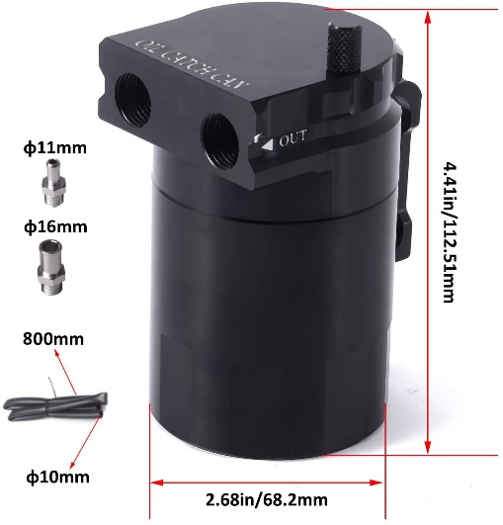

The can above is typical of the inexpensive and small sized cans available on Amazon or similar. The lower part of the can simply unscrews to empty. But I’m lazy. The wall thickness is thick enough to tap for an 1/8 NPT fitting for a Saf-Air or similar drain to make draining more convenient.
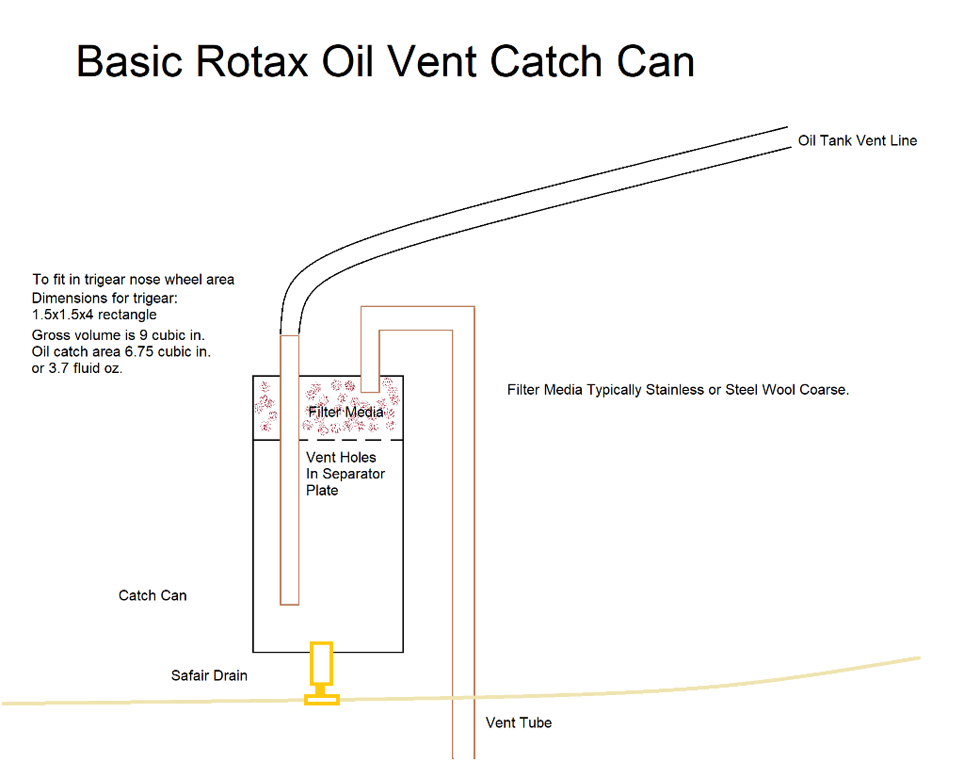
I have a trigear so, I have an area just behind the normal metal firewall area where I create an area for the nose gear trunnion. However, I was very neat, and the hole is rather tight and an automotive type unit won’t fit in this area without much extracurricular activity. The area under the oil tank in the turbo inlet would have to have a hole drilled to allow me to drain the oil. I wanted a smaller catch can as the oil amount is small and since I service the aircraft every 25 hours, why not just add a Saf-Air push to drain valve.

I chose to experiment using an ACS brake reservoir converted into an oil catch can. It has an NPT threaded hole in the top and one out the bottom. So, I have an inlet and drain. I just need to drill and tap for a vent out the side. But nothing is simple.

The ACS planned oil catch can is shown below. It is simply an inlet which flows the oil along a tube or side of the tank into a reservoir. Near the top of the can is a separator to prevent spraying oil from flowing out the vent. Many use a filter medium (basically coarse stainless-steel wool) to allow the vapor droplets to attach to the steel wool condense to form a droplet thus preventing oil droplets from flowing out the vent line oiling up the belly of the aircraft.
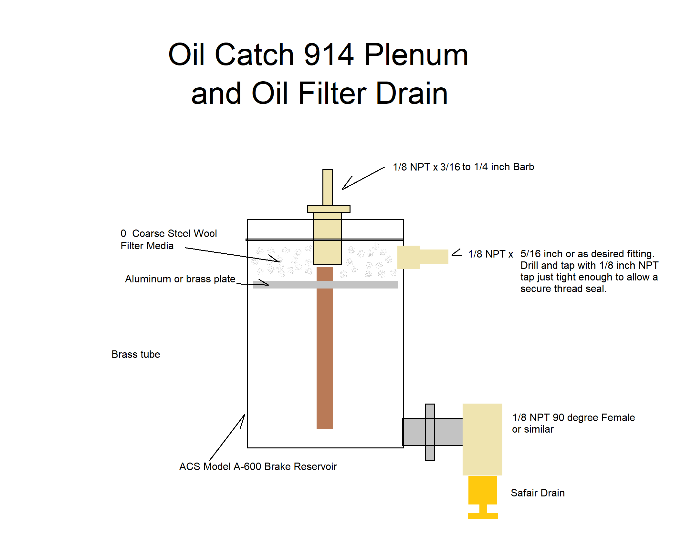
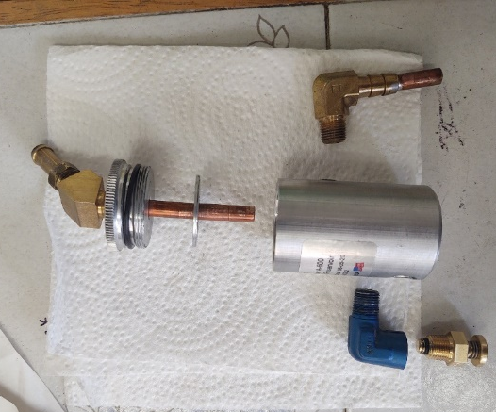

The can is small, and I used OO steel wool above the washer to filter out the oil spray.

Placement of the two ACS drip cans for experimental purposes was to attach the oil tank drain (right side) and the plenum catch can (on the left). Mono owners may want to attach the can to the port or starboard side of the cooler air duct or even in the 914 cowl exit or wheel well as clearance and installation patience allow. (912 owners may wish to add this simply to catch the vented oil film from the oil tank.) It can relieve you of that oily belly work you have to do annually and prevent the oil film from attaching to the walls of the main wheel well making the cleanup of this area less of a chore.
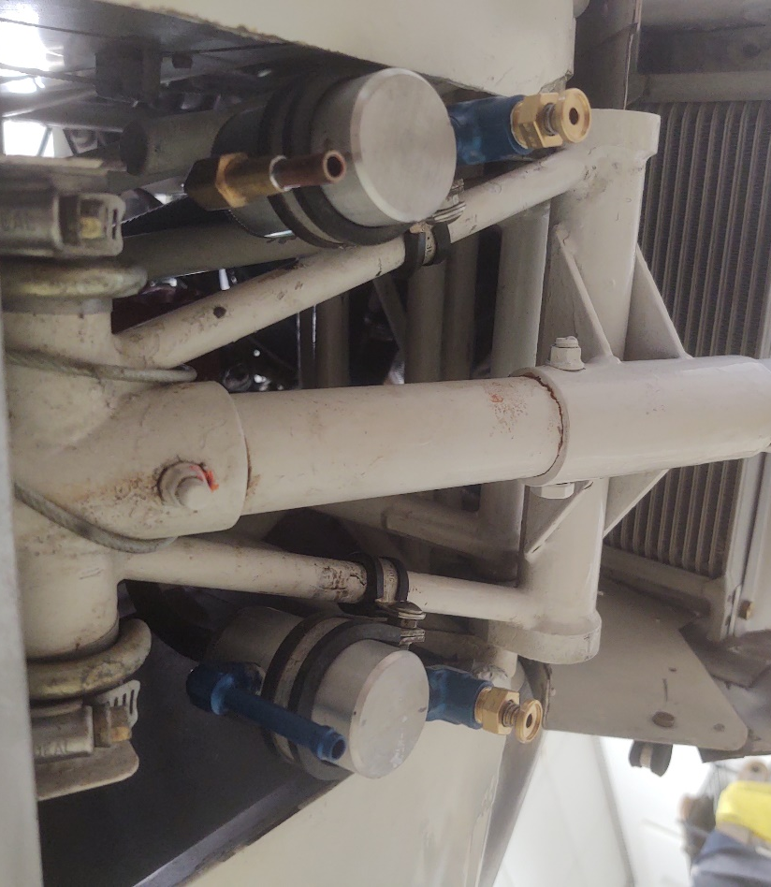

The can on the left catches the oil from the left and right side of the airbox of the 914. The can on the right catches the oil vent and the glycol vented film. There is quite a lot of glycol I never noticed before which is now mixed with the small amount of oil film from my oil vent line. Perhaps a separate can will be used for the glycol.

The next issue was the oil that drips from the bottom of the turbo oil reservoir under the turbo.
I fabricated a can from the bottom of a metal quart can found in the garbage of the shop. I cut it down, rolled the edges and inserted a small 5/32 OD brass tube as a drain. Of course, nothing is easy. The area I wanted to place the can was curved, the drain needed to be installed in the can to drain easily. I used my flaring tool to flare the brass tube end, dimpled the bottom of my catch can, then used a #8 brass washer and dimpled that to form a flush fitting drain. To seal the drain, I soldered the brass to the steel can and used the brass washer as a simple soldered in flange to permanently hold the brass tube firmly in place. Needless to say a mornings worth of work.

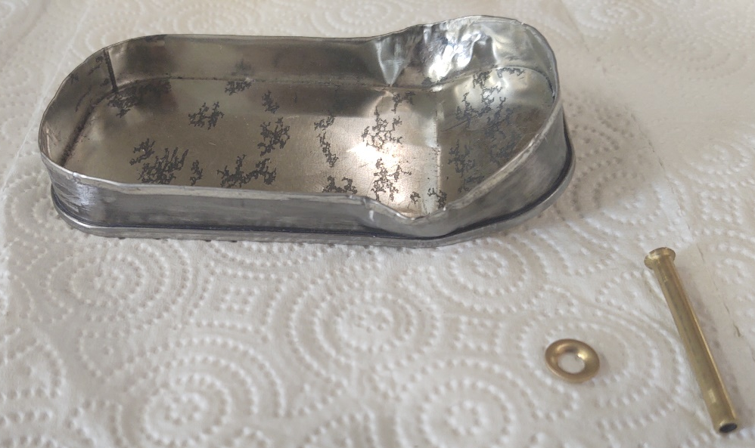
It is not pretty but it is an experiment only.

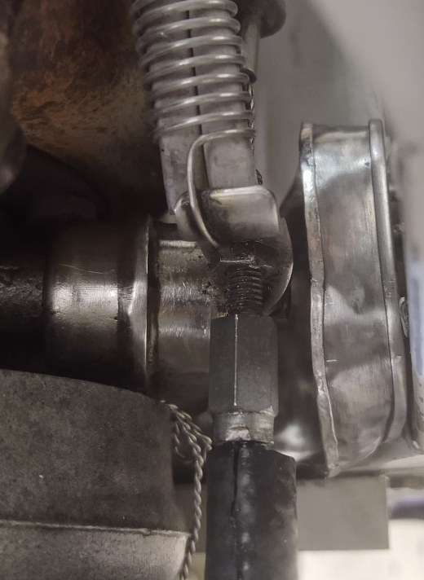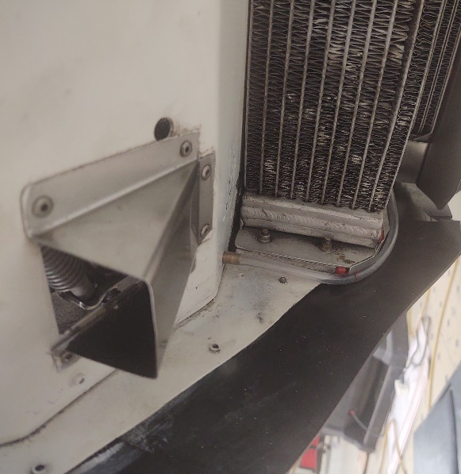
The drain is out of a drilled hole then will tuck under the rubber seal and exit the rear without any catch.

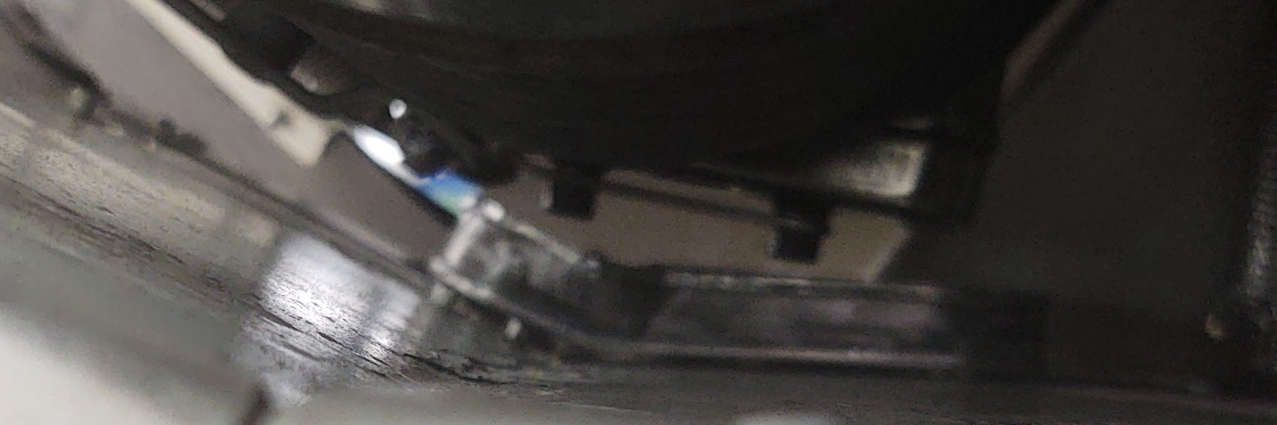
The drip tray under the turbo covers the area under the reservoir from front to back. Looking from the port side under the muffler the angled drip can sets right under the reservoir.

The three separate catch cans/drip tray should work. But as in any experiment, it will require tweaking.

So far, my ground test results are mixed. The under turbo catch can has been a waste of time but we will see after 25 flight hours. Of course, my 2 inch turbo air charge tube from my turbo outlet to the plenum was a greasy mess and required tightening of the clamp. Looks like a change of the rubber hose will be in the cards soon. This time I’ll use some silicone turbo hose and modify my turbo duct to clear the tube better.

The tank vent seems to work fine, but time will tell. It has only a couple drops of oil and water from vapor oil so far in the tank from the ground runs.

The carb plenum catch can has been a big help. This caught all the plenum oil from my initial ground runs. I find I can simply tilt my reservoir can and drain every bit of the oil using the Saf-Air drain.
I have not considered a catch can for the glycol necessary at this time. Since my engine has just had maintenance, I noticed my cylinder temps with the cowl on at full power are climbing much more rapidly. I’m getting a small amount of boiling in my glycol and the reservoir tank fills nearly full. This is common after maintenance as the slightest pressure leak causes elevated glycol temps and when the cylinder temps hit about 250F and a shutdown is made shortly thereafter, some steam will escape. Boil over in my aircraft is normally due to a small pressure leak raising the boiling point of the 50/50 mix glycol. I suspect a small hose leak after the cylinder head maintenance and found a pinhole crack in one of my lower coolant lines which was reused after the head maintenance.

As for the turbo inlet dripping oil, I have 3 D printed (I could have made one from PVC pipe) I fabricated a small catch for my air filter. What a pain to make and ensure that it won't get sucked into the turbo. It is just a plate that contacts the lip of the turbo inlet then has a depression for the oil to settle in. It works OK so far. Oil does drain down and out through a tube. If the oil puddle builds up under the engine, then it is probably prudent to suck the oil out of the turbo. Or just start up, run the engine, then go to the wash rack and wash off the oil spatter on the aircraft belly, gear and wing. Good news for the mono is the brake is on the opposite side of the tire from the exhaust.

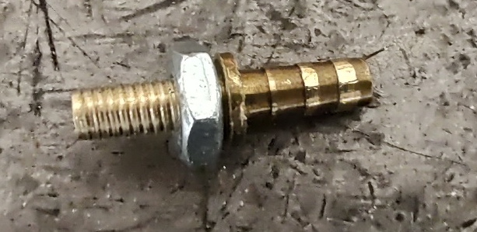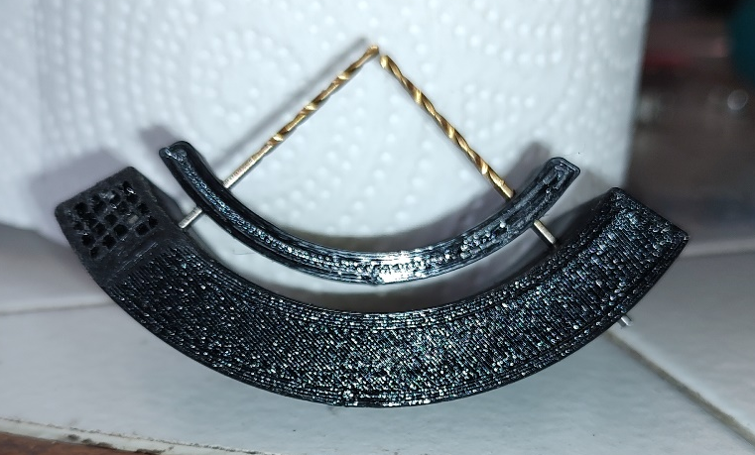
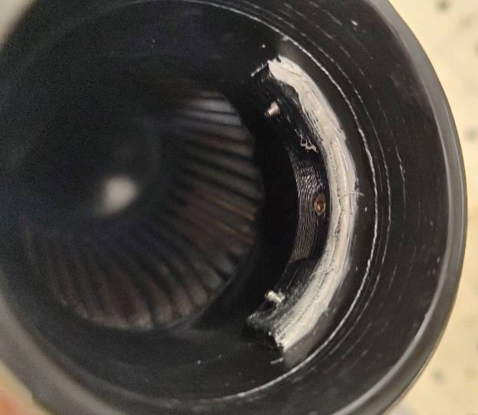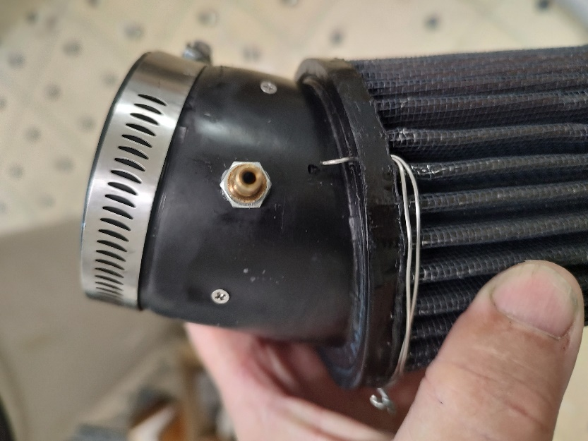

The above oil catch was a couple of weeks out of my life and frankly, was it worth the time, in my opinion for my airplane it was fine. Making a brass nipple, the 3 D printing, and threading, then sealing and routing the small oil drip line was as much of a pain as was the oil soaked fileter.

I have always said a Rotax should not leak oil or glycol. However, after any maintenance of the oil or coolant lines one must do an extensive leak check. My high CHT issue on runs was most likely the slight pressure leak in my cooling system, and a clamp was tightened, and more extensive checks will be made. It’s time for a 5 year hose change anyway. Time to go all silicone cooling hoses.

Note: I discovered my water/glycol radiator had a small leak. I was slowly leaking pressure. So, I’m awaiting a new radiator and radiator cap.

Always do a leak check after maintenance of the engine and especially after major maintenance. Even a simple oil change requires more than just a quick check at idle then cowl up and go fly. I prefer to run up and do a full power check on the ground.

Here are some maintenance related issues I’ve seen over the last 20 years to double check prior to an engine run after oil system and cooling system hose maintenance chores.
- Oil filters are messy if not properly seated. Always lube the oil seal prior to installation. I fill my oil filter prior to install, so it is necessary to use rags or paper towels to catch any spillage. Don’t catch the rag/towel in the oil filter O ring or fail to follow the tightening instructions. Once installed I have never had a Rotax oil filter loosen or leak.

- Another issue is sealing the magnetic plug. This 18 foot pound plug has a new hex head fitting and is predrilled for safety wire. I like this new unit, but I find its threads are a bit loose and I used Loctite 515 sealant on the threads to prevent drip. I question if it needs to be as tight as the manual says. Especially using 515 sealant.

- The oil tank vent line is a messy drip after flight in any Rotax 9 series. The tank should only have an inlet pressure of about 5 PSI max from the crankcase so a 5/16 sized hole to exit should not spray oily vapor. I have no idea what the pressure is from the turbo oil return. It can’t be that much pressure as the line is only an ID of 3mm. The only requirement should be to have the drain hose run downhill and exit the aircraft at a zero pressure point. Be sure to not angle the vent to cause suction or pressure at the vent as it affects the crankcase return pressure.

- Double check your turbo charging and plenum and carb connection hoses. Simple rubber hose gets slimy and slippery and can pop the plenum off under full boost. The new Viton lined (EPA approved marine grade) hose works well and the clamps hold well on the 914. I don’t use all silicone hose from the plenum to the carb unless a tough outer liner protector layer is on the silicone hose or liner as I fear the existing clamps will cut the silicone from clamping.

- One other messy drip source is the oil can lid itself. I recently had a few sprays on the upper side of the turbo inlet metal duct from my oil can O ring seal. The tank top sat proud of its normal position due to the metal screen not seated fully down on the lower baffle which inhibited the can top from seating and sealing with the O ring. At full power the pressure builds in the crankcase and can and the oil will spit out of the seal and all over your engine compartment.

Note:
The oil can bottom baffle (7) fits inside the oil screen (6). It is designed to fit up against the can top (4). Oil that enters the “IN” fitting (9) flows crankcase oil and gases into the oil tank and impacts directly on the seal area, so you must have a good seal of that O ring. I do not use sealant on the oil tank.
I carefully rolled the prickly edges of the screen (6) and made sure the fit of the screen was flawless. I installed a new O ring, rotated and checked the fit, and all was fine.
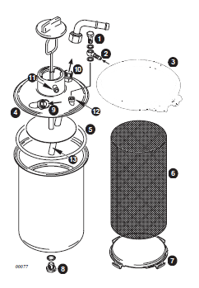

I run 100LL fuel all the time and I believe after the last cleaning I was less than careful seating my oil screen. It is now a thing of beauty and fits flawlessly. Of the 4 areas of oil leaks I found the maintainer was the issue. Any drip of coolant or oil from your Rotax must be investigated. Once you investigate, it is usually something simple.

As my father always said, “Go slow and take your time. Do it right the first time.”

