Changing tires in the field or hangar on the Europa XS Mono or Trigear.
By Bud Yerly

There are a few things most pilots don’t think about until it happens. One is a simple tire failure. Normally a tire failure is due to a puncture but the most common is an underinflated tire that spins on the rim. Flying with under inflated tires is a problem.

Mono:
The mono’s unique landing gear shock absorption is quite springy. To counter the hoppy mono, normal convention is to underinflate the tire to 16 pounds. I admit this works, but an 8 inch turf tire of 4 plies tends to bulge something fierce and can actually drag on the frame and fail. So most choose a 7 inch, 6 ply tire and inflate this stiffer tire to 16 PSI which gives a comfortable squish on landing with one aboard. With a fully loaded mono I prefer 18 PSI but the plane is a bit hoppy when solo.

In the event of a blown tire, keep the aircraft straight ahead until down to a slow taxi. Carefully and slowly taxi to a safe area and shut down. There is very little ground clearance with a failed tire and the possibility of a shredding tires rubber chunks can and will rip out brake lines and other items in the wheel well.

Jacking a mono: my preferred method is to remove the top cowl, use a 600 pound strap wrapped around the engine frame two or three times and then use an engine hoist or wrecker truck to hoist the aircraft. Place the aircraft on a tire dolly and carefully tow the aircraft to a safe work area. Once in a safe area, I hoist the aircraft and commence with the tire change.

Others have a unique piece of kit that attaches to the main gear frame and a floor jack can attach to this tool and elevate the entire aircraft. Care must be taken to assure the jack securely attaches to the tool and the aircraft is blocked to prevent it from falling off on a wing. The tool must be sufficiently strong to do the job. I prefer an aluminum or steel block because it can be built robustly, but a properly glued and screwed wood block will do the same job. This is an excellent piece for field tire changes when off station because it uses a simple jack, and saw horses to accomplish elevating the aircraft sufficiently to change a tire.
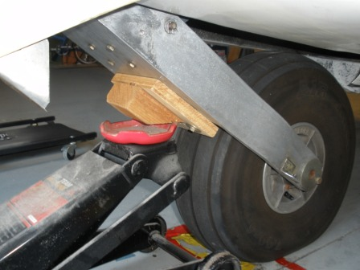

A wood block properly glued and screwed with good hardwood will work fine but avoid soft wide grain wood if possible. Be sure to get the angle from the gear to the jack at a safe angle as shown below:

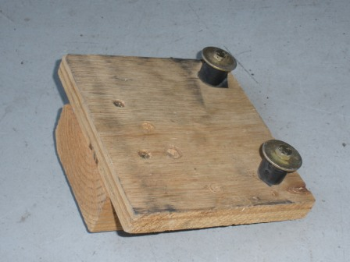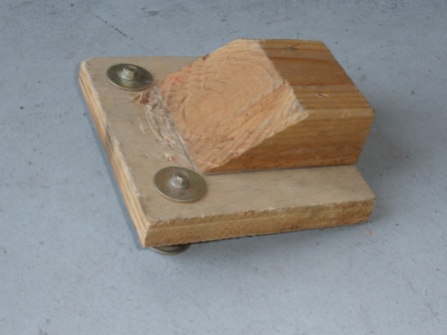

Although I prefer my overhead hoist, a simple engine hoist can lift a Europa XS. Most engine hoists do not have a long enough arm and leg supports to clear the spinner on most Europa tail draggers or mono’s, so if using an engine lift, pull the spinner off to save some dents.

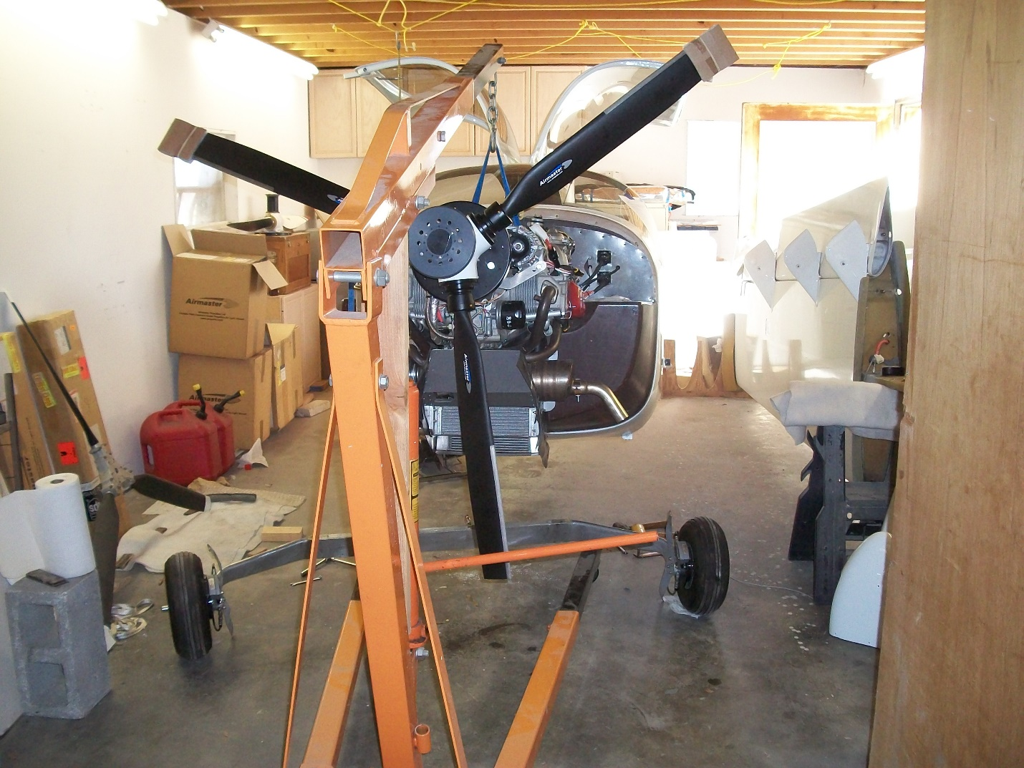
Trigear:
Jacking a trigear is fairly simple for shop and field work and little force is required.
A nose wheel/tire is easy to get off the ground as it only requires about a 100 pound weight on the tail to raise and hold the nose securely. Personally, all my clients have a secure tail tie down built into the aircraft’s tail for tiedown, and to hoist the nose. For those who do not have a tail tie down, simply remove the stabs and sling strapping or rope around each side of the stab tube attached to a floor weight to raise the aircraft’s nose. (I have two filled concrete blocks for this task in the shop to elevate the nose.) If the stabs will not come off, and you are alone, you’re in trouble as a wide sling around the dorsal fin near the stab leading edge that is well padded may work well but there may be paint damage unless padding is well placed.

Nose tire change Neanderthal method:
One or two guys can simply push down on the tail dorsal and hold it long enough for you remove the axle bolt and pull off the wheel, then carefully lower the aircraft to a clean block of wood or similar pad to protect the fork. If you don’t have one or two large guys, add some extra weight to the baggage bay, 100 pounds in the XS baggage bay and with a full fuel load, the tail can be pushed down quite easy. In fact, because of the geometry of the trigear, the tail may stay pinned to the ground with only a common jacket, your wife or child or a light weight set on a stab to hold the tail firmly to the ground long enough to get your wheel and tire removed, lowered to a padded block and take your nose wheel to the bench.

Main tire change:
My preferred method is to insert a 12-16 inch long steel ½ inch water pipe (which is .84 inches or 13/16 inches in diameter) into the spindle about 3-4 inches. This will require you to remove the wheel pant insert and cotter pin to insert the pipe of course. The method is excellent for annual shop work. I prefer to use my floor jack to quickly raise the wheel/tire, however on flat tires the clearance is not sufficient to get a jack under the tip of the pipe, so I use a small scissor jack commonly found in auto part stores or the wheel well of your compact car.

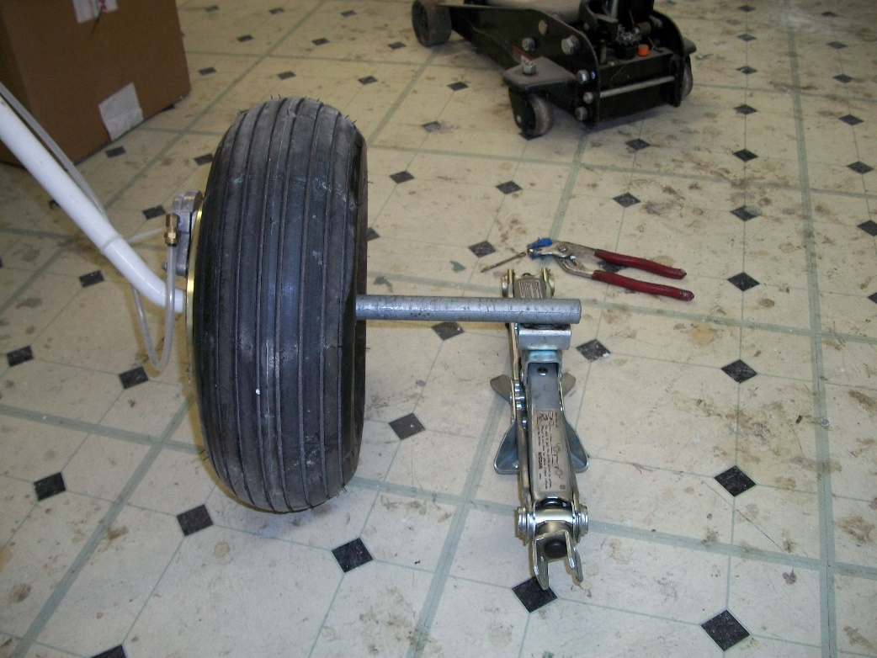
Wheel pant removed.
Another neat tool is the RV jacking tool from Aircraft Spruce:
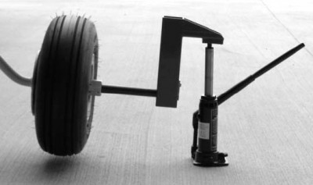
RV JACK STAND KIT
$59.85/Each

Once the tire is clear of the floor, the axel bolt can be removed and slid toward the jack, along with the wheel/tire and bearings. All one must do is place a wood block under the spindle using some padding to protect the spindle from any floor dirt. I use two short pieces of 4x4 wood as my spindle support. Lower the jack and pull the wheel and bearings and tube/pipe off and service the wheel and tire.

The Archimedes method:
In the field when confronted with a seriously flat tire, I remove the wheel pant first and pull the cotter pin and pant support. I simply go to my shop or hardware store, get a piece of water or gas pipe, and an 8 foot 2x4 to raise the flat tire. I place the 2x4 to get sufficient leverage to raise the pipe/tire/aircraft sufficiently to get a floor or scissors jack under the end of the pipe. Then jack as I do in the shop. When working alone in the shop, I use the 2x4 and blocks to keep the lever elevated while I position the jack.

Neanderthal method:
In a pinch I use the strength of the Europa and a couple airport helpers. Again, the pipe and blocks are necessary, but by putting my back under the main spar and simply pushing up by straightening up my knees to lift the aircraft. A helper can install an airport floor jack or block under the end of the pipe. Then all one needs to do is remove the wheel/tire and with a spindle block ready, I raise the aircraft sufficiently to support the spindle and get on with the tire change. The area I prefer to lift is on the spar, abeam the outer flap hinge where there are ribs to prevent flexing the lower wing skin. It’s important to spread the load and my back is sufficiently wide to do just that. It is remarkably easy. If you have a helper to push down on the opposite wing near the spar end just inboard of the tip (on the rib) it requires very little back strength and a surprising light amount of pressure on the opposite wing (we’re talking skinny line boy).

Never attempt to jack the Europa using conventional aircraft wing jacks under the Europa wing or even the Europa supplied wing tie down support. These type jacks are made for a specifically designed wing support point for only that specific airplane.

